**LAB 09**

**Part 1: (1),(2),(3)**

**(1).Changing the lantent space size**

* latent space size = 100

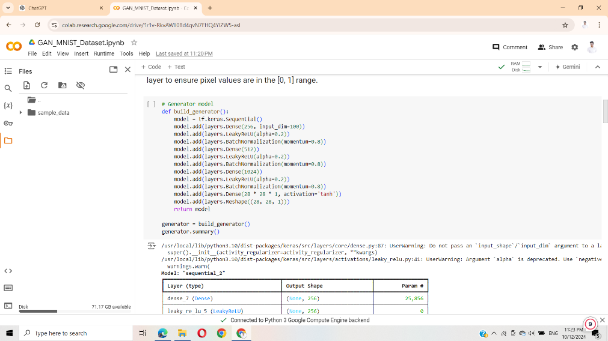

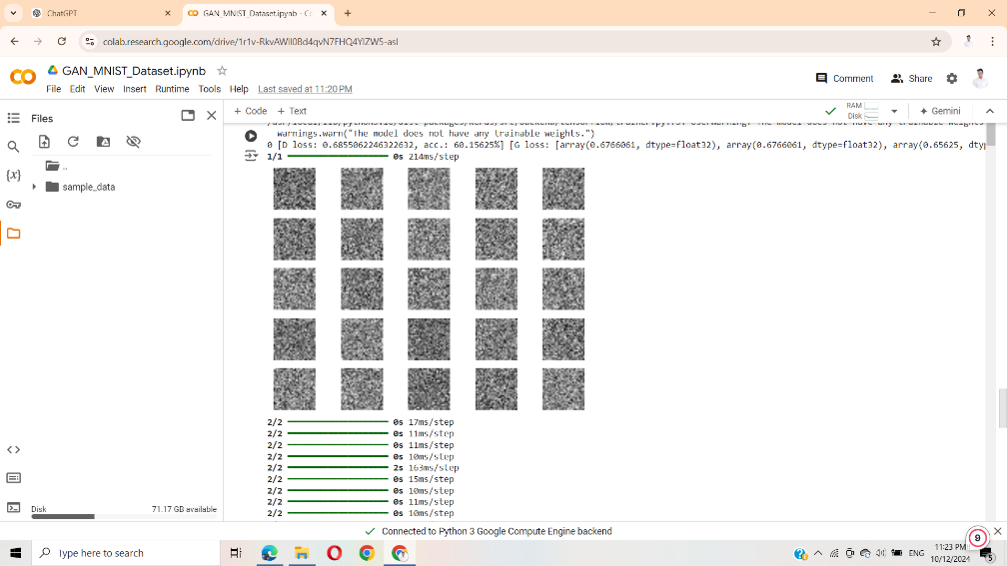

* latent space size = 50

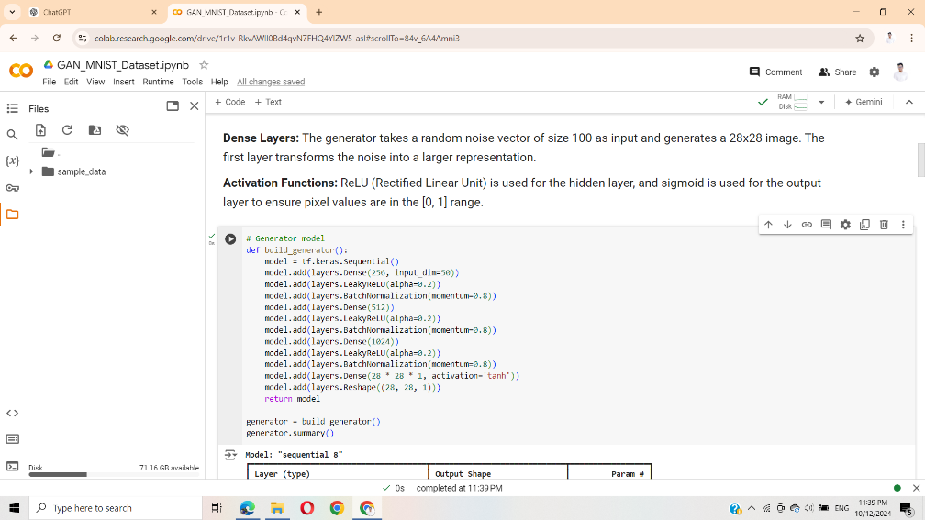

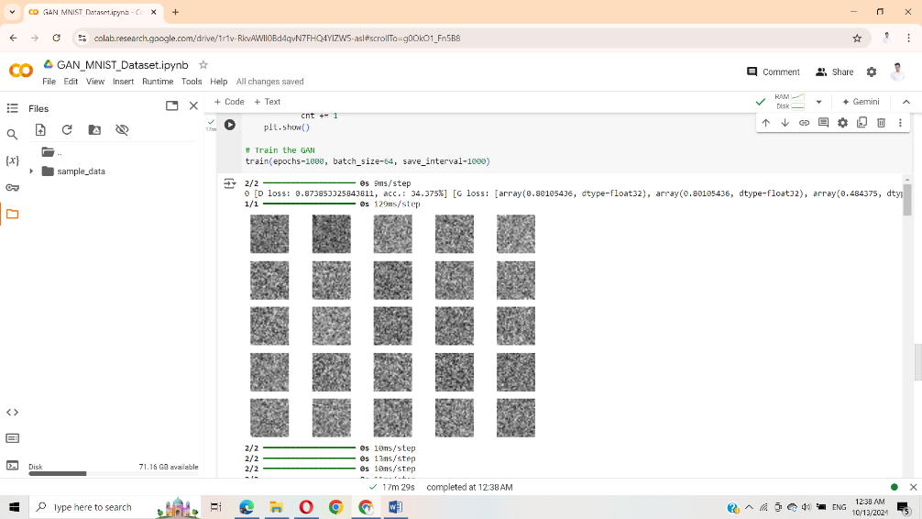

• Reducing the latent space size from 100 to 50 dimensions leads to faster training and simpler images, but at the cost of reduced diversity and potentially lower image quality.

• In applications requiring high-fidelity images (like faces or complex textures), a larger latent space would likely be more beneficial. However, for simpler datasets like MNIST, where the variability is relatively low, a smaller latent space can still produce reasonable results without overfitting or excessively long training times.

**(2). Generate the Gif**

Generated Gif

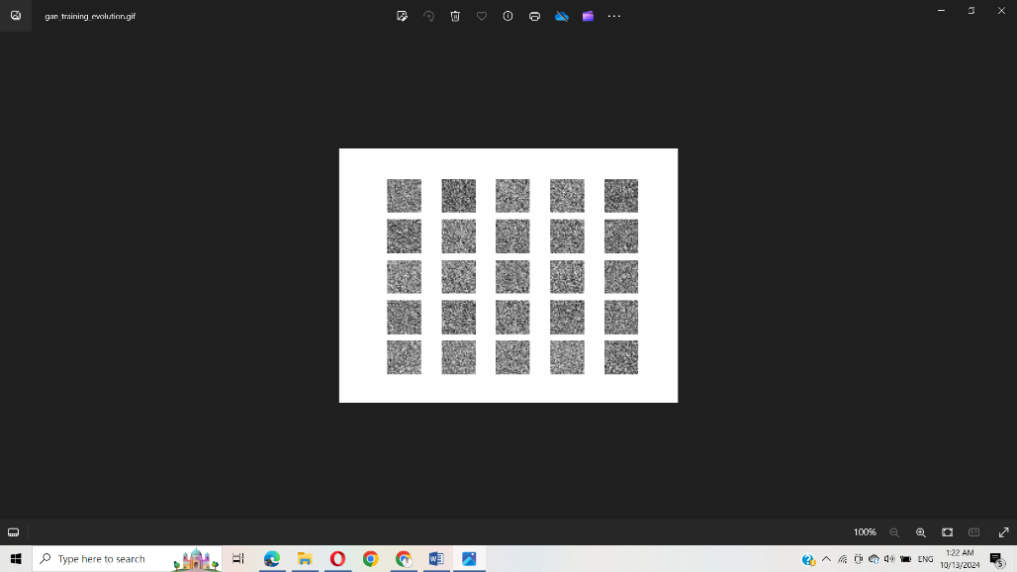

Generated Image

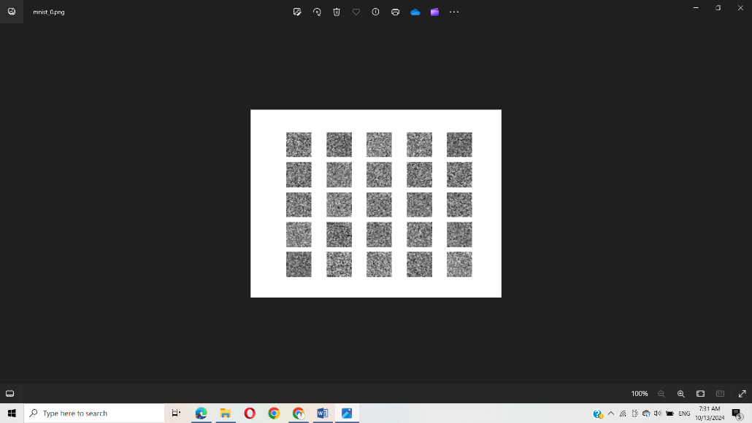

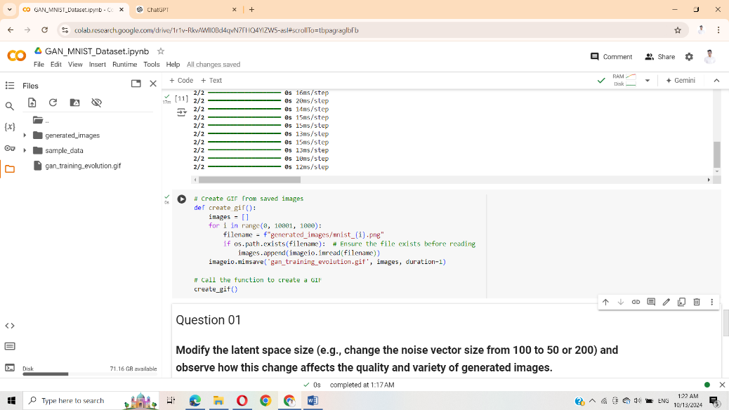

**(3). Change the optimizer from Adam to RMSprop or SGD**

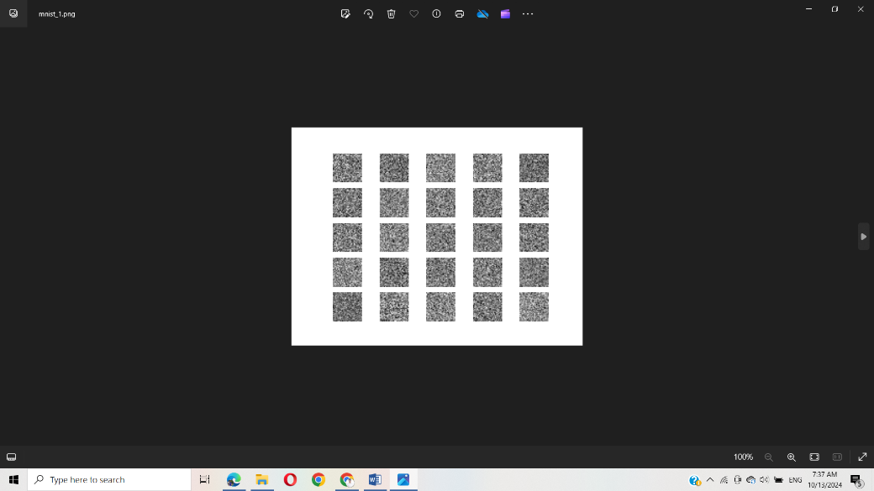

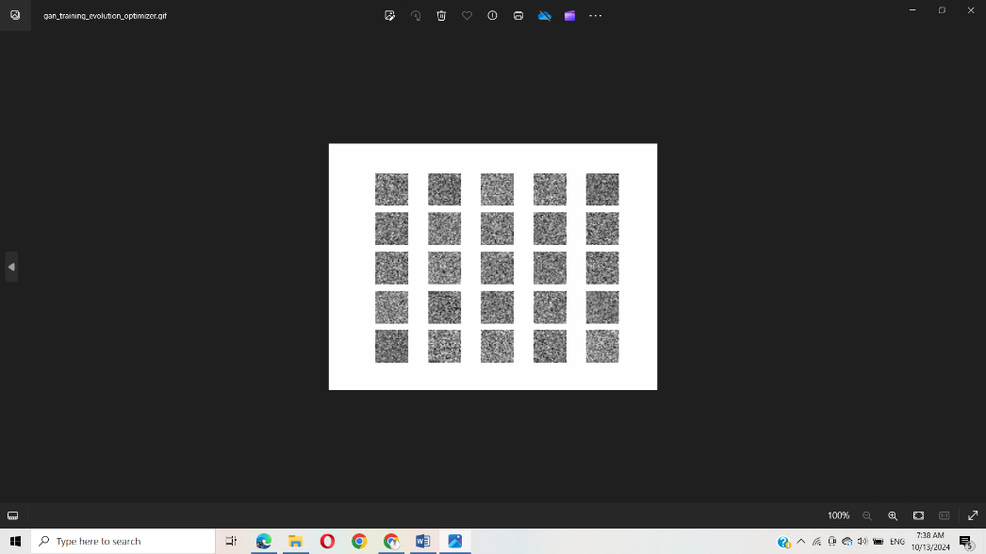

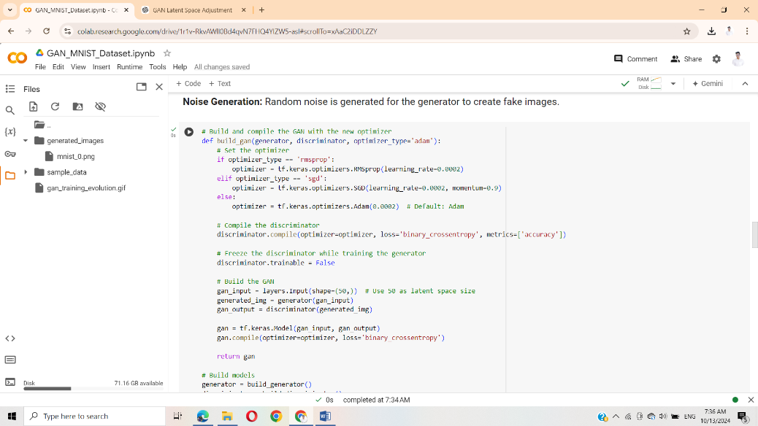

• When set RMSprop:

* Training Performance: RMSprop tends to stabilize the training. The learning process is generally smoother, with smaller fluctuations in the losses (both generator and discriminator).
* Image Quality: Images typically improve more gradually over time. RMSprop helps in preventing large jumps in quality, leading to clearer images as training progresses. However, the overall training might be slightly slower compared to Adam.

• When set SGD:

* Training Performance: SGD, especially without momentum, often results in more unstable training. The losses fluctuate more widely, and the training can be slower.
* Image Quality: With plain SGD, image quality can improve, but it happens more slowly. The generator may struggle to learn effectively early on. Adding momentum helps speed up convergence, but images may still not reach the quality seen with RMSprop or Adam as quickly.

**(4). Experiment with different batch sizes**

* Batch Size = 64

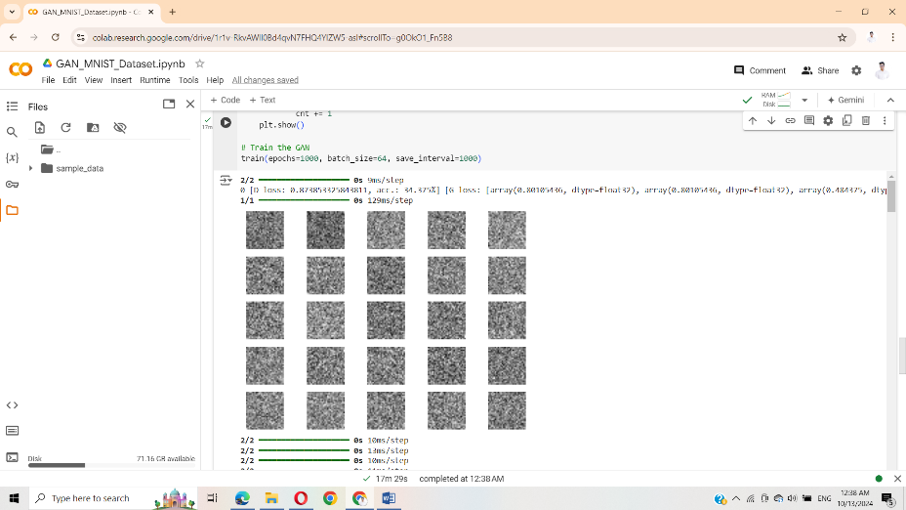

* Batch Size = 32

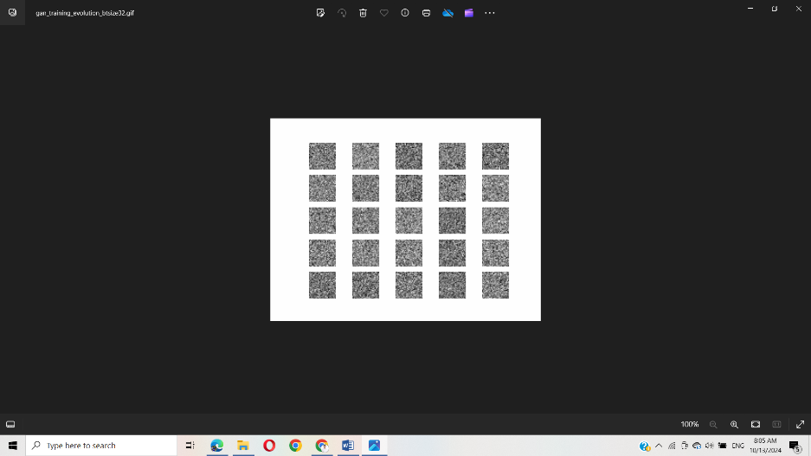

When batch size set to 32 it isTraining may be less stable than the 64.And also Since fewer images are processed at once, each training step is faster than the 64. As well as The generated images in batch size 32 may vary more due to the noise introduced by the smaller batch sizes.

When batch size set to 256 it isTraining may be high stable than the 64.And also Since fewer images are processed at once, each training step is lower than the 64. Image quality tends to improve more quickly with large batch sizes like 256.

**Part 2: (1),(2),(3)**

**1. Modify the CGAN**

**2. label smoothing by replacing real labels of 1 with random values between 0.9 and 1**

**3. Create noise vectors**

**Part 3: (1),(2),(3),(4)**

